**TODO APP PROJECT REPORT**

**INTRODUCTION**

**Overview :**

ToDo List App is a kind of app that generally used to maintain our day-to-day tasks or list everything that we have to do, with the most important tasks at the top of the list, and the least important tasks at the bottom.

**Purpose:**

To-do lists offer a way to increase productivity, stopping you from forgetting things, helps prioritise tasks, manage tasks effectively, use time wisely and improve time management as well as workflow.

**LITERATURE SURVEY**

**Existing problem:**

**•** Maintain a To-do which is minimal and clear.

• Make sure you tick the completed task as soon as it is done.

**•** when you get back to your next tasks, eliminate external and internal distractions.(phone on airplane mode, drinking water, etc)

**Proposed Solution:**

**•** Todo apps are widely used, but different users use the apps differently depending on their particular needs. In order to identify the problems faced by users of todo apps, I conducted research to develop an understanding of the market and users’ needs.

**THEORITICAL ANALYSIS**

**Block diagram:**

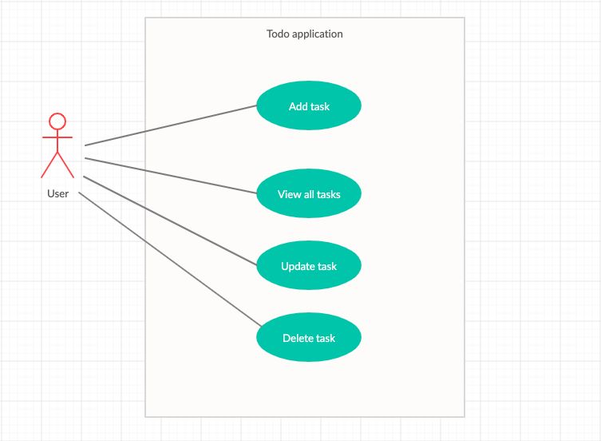

**RESULT** :

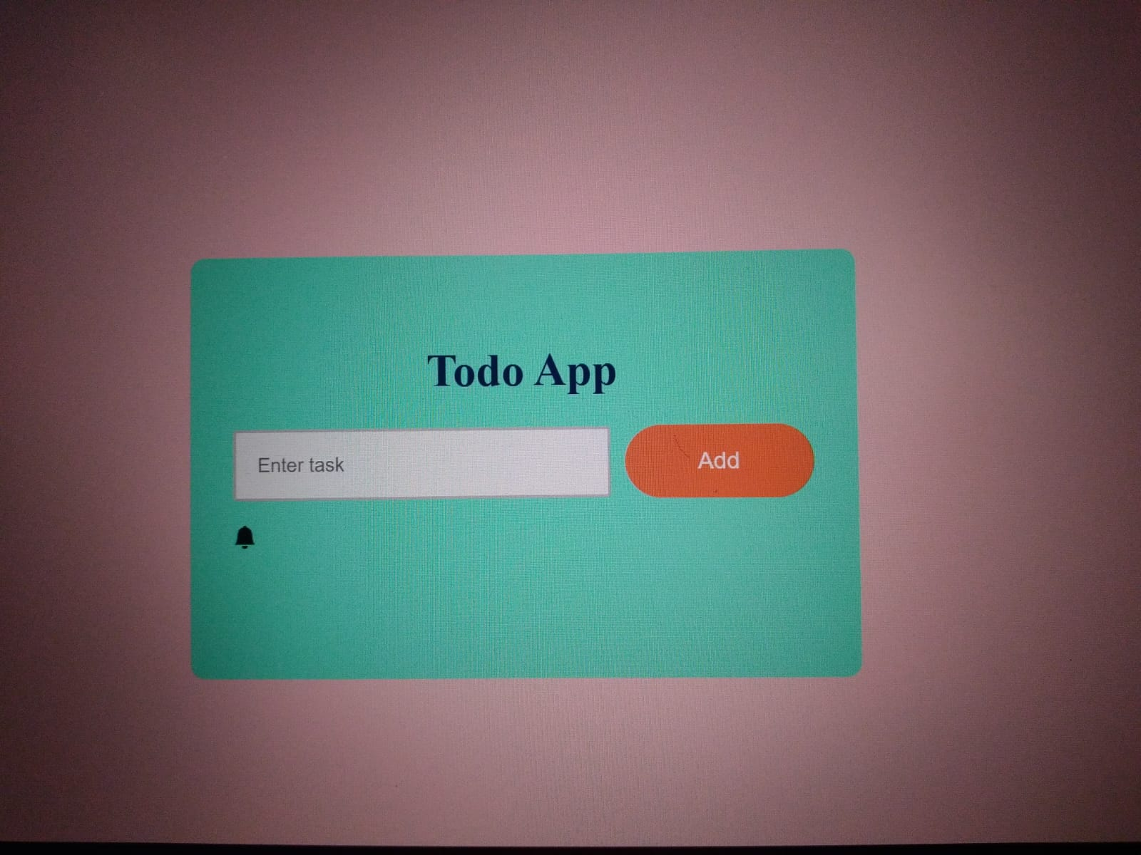

**ADVANTAGES:**

**•** Increases productivity.

• Provides motivation.

• Improves memory.

• Reduces stress.

• Allows for more personal time.

**DISADVANTAGES:**

**•** Allows you to avoid these tasks as long as possible.

**•** Promotes procrastination and task avoidance.

**•** A lengthy running to-do list can be intimidating and cluttered.

**APPILICATIONS:**

• Microsoft To Do

• Google Tasks

• To Do List

• Daily TODO List – Calendar.

**CONCLUSION:**

Whether you need a to-do list or not is of personal preference. If you, however, keep a to-do list, it's imperative that you get the inversion: a not-to-do list. It helps to weed out the unwanted stuff and focus on the things that matter most.

**FUTURE SCOPE:**

We’re addicted to compile never-ending to-do lists and it feels so good to check off items as we progress with our work. But we hardly manage to clear our list by the end of the workday.

It’s only natural that we want to keep stock of what we’re supposed to do, but only a few will keep stock of stuff that won’t get done. That leads us to the not-to-do list, which is as much important as the to-do list itself.

**Developed By:**

**@Satti Madhu Priya**

**@Rachapothu Raj Kumar**

**@Giduturi Anand**

**@Sunkara Kalyani**

**@Somani Jayanth**